A Survey on the Semi-automated Serious Educational Games
for a New Approach in the
Serious Educational Game Development Platform

TR xxxxx

Dr. Kendra Cooper

Golsa Mirbagheri

Acknowledgements

xxx.

Abstract

yyy.

Table of Contents

Acknowledgements 2
Abstract 3
Table of Contents 4
1. Introduction 6
2. Comparison Criteria 7
2.1 Goals of Automation 7
2.2 Foundation for Automation 7
2.3 Pedagogical foundation for the Automation 7
2.4 Validation Tool Support 8
3. Automation in Game Applications 8
3.1 Serious Games 8
3.1.1 Modding as an Open Source Approach to Extending Computer Game Systems 8
3.1.1.1 Introduction 8
3.1.1.2 Comparison Criteria 11
3.1.2 Fully Automatic Adaptation of Interfaces - The case of 1492 12
3.1.2.1 Introduction 12
3.1.2.2 Comparison Criteria 13
3.1.3 Semiautomatic Adaptation - The case of "My first day at work" 13
3.1.3.1 Introduction 13
3.1.3.2 Comparison Criteria 15
3.1.4 Petri Nets for Representing Story Plots in Serious Games 15
3.1.4.1 Introduction 15
3.1.4.2 Comparison Criteria 17
3.1.5 Applying Cellular Automata and DEVS Methodologies to Digital Games 18
3.1.5.1 Introduction 18
3.1.5.2 Comparison Criteria 20
3.2 Entertainment Games 21
3.2.1 Toward Supporting Stories with Procedurally Generated Game Worlds 21
3.2.1.1 Introduction 21
3.2.1.2 Comparison Criteria 23
3.2.2 Modeling Player Experience for Content Creation 23
3.2.2.1 Introduction 23
3.2.2.2 Comparison Criteria 25
3.2.3 Towards Automated Game Design 26
3.2.3.1 Introduction 26
3.2.3.2 Comparison Criteria 28
3.2.4 User-preference-based automated level generation for platform games 29
3.2.4.1 Introduction 29
3.2.4.2 Comparison Criteria 31
3.2.5 An Offline Planning Approach to Game Plotline Adaptation 32
3.2.5.1 Introduction 32
3.2.5.2 Comparison Criteria 34
4. Automation in E-learning Application 35
4.1 Automatic Facial Expression Recognition for Intelligent Tutoring Systems 35
4.1.1 Introduction 35
4.1.2 Comparison Criteria 37
4.2 Automating e-Learning: The Higher Education Revolution 37
4.2.1 Introduction 37
4.2.2 Comparison Criteria 39
4.3 Recommender system based on user-generated content 40
4.3.1 Introduction 40
4.3.2 Comparison Criteria 42
4.4 E-learning recommendation system 42
4.4.1 Introduction 42
4.4.2 Comparison Criteria 44
4.5 EXPERT PERSONALIZED E-LEARNING RECOMMENDER SYSTEM 45
4.5.1 Introduction 45
4.5.2 Comparison Criteria 46
5. Conclusions and Future Work 47
5.1 Table of Comparison Criteria 47
6. References 50
Appendix A. title here 51

Introduction

// a place to start is one paragraph for each of these:

Intro. to changing educational needs, how e-learning fits into that shift (include definition with reference for e-learning)
Intro. to serious educational games (include definition with reference of serious educational game)
Intro. to automation in serious education games (what other researchers have automated)
Intro. to the SimSYS Game Development Platform (overview, with references)
Focus in on the intelligent semi-automated game generation component
Why is this research needed?
Brief overview of the component, research methodology (including validation), and results
Structure of this report

Comparison Criteria

Goals of Automation
In its simplest form, a narrative is a sequential presentation of events. States, important points or actions are necessarily described in order over the time of presentation- a linear plot graph, for example. In this sense a narrative is a total ordering of events. However, the presentation of a narrative is often regarded as secondary to its internal semantics. Internal, narrative time, for instance, can allow for two events to occur concurrently (\meanwhile:::"); the relating of these two events is then an interleaving of the narrative's necessary ordering.
Plot DAGs Internal order-relations, such as narrative time or physical causality, produce a \plot DAG" (Directed Acyclic Graph). The plot DAG is a graph representation of the significant events/states in a narrative ordered by the internal system: each node represents a state, and directed edges between nodes represent necessary precedence. Since events in a traditional narrative do not repeat, the overall structure is acyclic [1].
Procedural content generation (PCG) is an increasingly important area of technology within modern human-computer interaction (HCI) design. Personalization of user experience via affective and cognitive modeling, coupled with real-time adjustment of the content according to user needs and preferences are important steps toward effective and meaningful PCG. Games, Web 2.0, interface, and software design are among the most popular applications of automated content generation [2].

Foundation for Automation
Scientific methods and technologies that improve efficiency, productivity, quality, and reliability, specifically for methods, machines, and systems operating in structured environments over long periods, and the explicit structuring of environments.
User interfaces to games embody the practice and experience of interfacing users (game players) to both the game system and the play experience designed by the game's developers. Game developers act to constrain and govern what users can do, and what kinds of experience they can realize. Some users in turn seek to achieve a form of competitive advantage during game play by modding the user interface software for their game, when so enabled by game developers. These modes acquire or reveal additional information that users believe will help their play performance and experience.
Three kinds of user interface customizations can be observed. First and most common, is the player's ability to select, attire or accessorize a player's in-game identity. Second, is for players to customize the color palette and representational framing borders of their game display within the human-computer interface. Third, are user interface add-on modules that modify the player's in-game information management dashboard, but do not modify the underlying game play rules or functions [3].

Pedagogical foundation for the Automation
In pedagogical foundation on Serious Educational Game, 5 areas called prediction-observation-explanation (POE), Self-explanation, Collaboration, Problem-Based Learning (PBL) and Guidance, reflection, and interactivity will be evaluated.

- The prediction-observation-explanation (POE)
A prediction-observation-explanation model is a potential approach to increase learners’ conceptual change.
- Self-explanation
Self-explanation is a method that prompts students to generate their own explanation orally, in writing, or through replying to a multiple-choice question.
- Collaboration
Collaboration refers to a situation that two or more students work together on constructing knowledge and solving problems. In a game environment, collaboration enables players to guess and discuss about game moves, strategies, or arguments.
- Problem-Based Gaming (PBG)
Problem-Based Learning (PBL) is an ideal way to engage learners in cognitive processes so that they can build knowledge or develop skills to solve problems effectively.
- Guidance, reflection, and interactivity
The researchers conducted three experiments to investigate how students’ deep learning was enhanced in an agent-based multimedia game that integrates instructional methods: guidance (the agent explains why an answer is accurate), reflection (learners are prompted to explain why an answer is accurate), and interactivity (learners are asked to respond to a problem instead of receiving an answer from the agent). The results show that ether guidance or reflection was able to support students’ science learning in a game context. In addition, reflection also fostered retention and far transfer only when the students were encouraged to reflect on the correct solutions provided by the agent (interactivity). That is, if asked to reflect on their own solutions, the students might not benefit from playing the game [4].

Validation Tool Support
Automated Verification System: A software tool that accepts as input a computer program and a representation of its specification and produces, possibly with human help, a proof or disproof of the correctness of the program. Any software tool that automates part or all of the verification process [5]. Assessment has become a subject of great interest to engineering educators. This is part of a larger trend toward emphasizing student learning outcomes in higher education, undertaken both to demonstrate accountability and to improve instruction. Traditionally, engineering educators have focused assessment around students' mastery of content knowledge and skills [6].
Internal educational validity indicates to what extent learners achieve the learning/performance/skills expected by the game/simulation (e.g., decision-making skill, prediction accuracy, cooperation, motivation). The measures can be either the performance indicator provided by the game/simulation (e.g., total sales, total profit), or the ones designed based on the expected outcomes from the game/simulation. External educational validation refers to whether the learning/skills expected by the game/simulation matters or relevant in the real world. Representational validity is the basis of educational validity [7].

Automation in Game Applications

Serious Games

Modding as an Open Source Approach to Extending Computer Game Systems

Introduction
This part examines what is known so far about the role of open source software development within the world of game mods and modding practices. Game modding has become a leading method for developing games by customizing or creating OSS extensions to game software in general, and to proprietary closed source software games in particular. What, why, and how OSS and CSS come together within an application system is the subject for this part. The research method is observational and qualitative, so as to highlight current practices and issues that can be associated with software engineering and game studies foundations. Numerous examples of different game mods and modding practices are identified throughout [3].

Four Types of Game Mods: At least four types of game mods are realized through OSS development practices. These include (i) user interface customizations and agents, (ii) game conversions, (iii) machinima, and (iv) hacking closed source game systems. Each is examined in turned, and each is facilitated (or prohibited) according to its copyright license.
User Interface Customizations and Agents: User interfaces to games embody the practice and experience of interfacing users (game players) to both the game system and the play experience designed by the game's developers. Three kinds of user interface customizations can be observed. First and most common, is the player's ability to select, attire or accessorize a player's in-game identity. Second, is for players to customize the color palette and representational framing borders of the their game display within the human-computer interface, much like what can also be done with Web browsers and other end-user software applications. Third, are user interface add-on modules that modify the player's in-game information management dashboard, but do not modify the underlying game play rules or functions.
Game Conversions: Game conversion mods are perhaps the most common form of game mods. Most such conversions are partial, in that they add or modify: (a) in-game characters including user-controlled character appearance or capabilities, opponent bots, cheat bots, and non-player characters; (b) play objects like weapons, potions, spells, and other resources; (c) play levels, zones, maps, terrains, or landscapes; (d) game rules; or (e) play mechanics. Some more ambitious modders go as far as to accomplish (f) total conversions that create entirely new games from existing games of a kind not easily determined from the original game.
Machinima: Machinima can be viewed as the product of modding efforts that intend to modify the visual replay of game usage sessions. Machinima employ computer games as their creative media, such that these new media are mobilized for some other purpose (e.g., creating online cinema or interactive art exhibition). Machinima is a form of modding the experience of playing a specific game, by recording its visual play session history, so as to achieve some other ends beyond the enjoyment (or frustration) of game play.
Hacking Closed Game Systems: Hacking a closed game system is a practice whose purpose oftentimes seems to be in direct challenge to the authority of commercial game developers that represent large, global corporate interests. Hacking proprietary game software is often focused not so much on how to improve competitive advantage in multi-player game play, but instead is focused on expanding the range of experiences that users may encounter through use of alternative technologies.
Game Modding Software Tools and Support: Games are most often modded with tools providing access to unencrypted representations of game software or game platform. Game/domain-specific Software Development Kits (SDKs) provided to users by game development studios represent a contemporary business strategy for engaging users to help lead product innovation from outside the studio. Once Id Software, maker of the DOOM and Quake game software product line, and also Epic Games, maker of the Unreal software game product line, started to provide prospective game players/modders with software tools that would allow them to edit game content, play mechanics, rules, or other functionality, other competing game development studios were pressured to make similar offerings or face a possible competitive disadvantage in the marketplace [3].
However, the CSS versions of these tools do not provide access to the underlying source code that embodies the proprietary game engine—a large software program infrastructure that coordinates computer graphics, user interface controls, networking, game audio, access to middleware libraries for game physics, and so forth. But the complexity and capabilities of such a tool suite mean that any one person, or better said, any game development or modding team, can now access modding tools or SDKs to build commercial quality CSS games through OSS extensions. But mastering these tools appears to be an undertaking likely to be only of interest to highly committed game developers who are selfsupported or self-organized.
In contrast to game modding platforms provided by game development studios, there are also alternatives provided by the end-user community. One approach can be seen with facilities provided in meta-mods like Garry's Mod or the AMX Mod X modmaking package. Modders can use these packages to construct a variety of plug-ins that provide for development of in-game contraptions as game UI agents or user created art works, or to otherwise create comic books, program game conversions, and produce other kinds of user created content. But both packages require that you own a licensed CSS game like Counter-Strike: Source, Half-Life2 or Day of Defeat: Source from Valve Software.
A different approach to end-user game development platforms can be found arising from OSS games and game engines. The DOOM and Quake games and game engines were released as free software subject to the GPL, once they were seen by Id Software as having reached the end of their retail product cycle. Thousands of games/engines, as already observed, have been developed and released for download. Some started from the OSS that was previously the CSS platform of the original games. However, the content assets (e.g., in-game artwork) for many of these CSSthen-OSS games are not covered by the GPL, and so user-developers must still acquire a licensed copy of the original CSS game if its content is to be reused in some way. Nonetheless, some variants of the user-created GPL'd games now feature their own content that is limited/protected by Creative Commons licenses [3].
Opportunities and Constraints for Modding: Game modding demonstrates the practical value of software extension as a user-friendly approach to customizing software. Such software can extend games open to modding into diverse product lines that flourish through reliance on domain-specific game scripting languages, and integrated SDKs. Modding also demonstrates the success of end-users learning how to extend software to create custom user interface add-ons, system conversions, replayable system usage videos, as well as to discover security vulnerabilities. Game modding therefore represents a viable form of enduser engineering of complex software that may be transferable to other domains.
Modding is a form of OSS-enabled collaboration. It is collaboration at a distance where the collaborators, including the game developers and game users, are distant in space and time from each other, yet they can interact in an open but implicitly coordinated manner through software extensions. Comparatively little explicit coordination arises, except when CSS game developers seek to embrace and encourage the creation of OSS game mods that rely on the proprietary CSS game engine (and also SDK), as a way to grow market share and mid share for the proprietary engine as a viable strategy to entry into the game industry. However, mods are vulnerable to evolutionary system version updates that can break the functionality or interface on which the mod depends.
This can be viewed as the result of inadequate software system design practice, such that existing system modularization did not adequately account for software extensions that end-users seek, or else the original developer wanted to explicitly prohibit end-users from making modifications that transform game play mechanics/rules or unintentionally allow for modification or misappropriation of copy protected code or media assets. Last, one the key constraints on game modding in particular, and software extension in general, are the rights and obligations that are expressed in the original software EULA. Mods tend to be licensed using OSS or freeware licenses that allow for access, part, modification, and redistribution, rather than using free software licenses (e.g., GPLv2 or GPLv3).
Software extensions that might be subject to a reciprocal GPL style license require that the base/original software system incorporate an explicit software architectural design that requires the propagation of reciprocal rights across an open interface, except through an LGPL software shim. Otherwise, the scope of effectiveness and copyright protections of either free or non-free software (or related media assets) cannot be readily determined, and thus may be subject to copyright infringement or licenses non-compliance allegations.
They may also be treated as social transgressions within a community of modders whose perceived ownership of the game mods demands respect and honor of a virtual license that may or may not be legally valid. As the OSS community has long recognized, software rights and freedoms are expressed through IP licenses that insure whether or not a person has the right to access, part, modify, and redistribute the modified software, as long as the obligation to include a free software license is included that restates these rights in unalterable form, is included with the OSS code and its modified distributions [3].

Comparison Criteria

Goals of the Automation
One approach can be seen with facilities provided in meta-mods like Garry's Mod or the AMX Mod X modmaking package. Modders can use these packages to construct a variety of plug-ins that provide for development of in-game contraptions as game UI agents or user created art works, or to otherwise create comic books, program game conversions, and produce other kinds of user created content.

Foundation for Automation
The modern Web architecture is itself designed according to principles of extensibility through open APIs, migration across software versions, network data content/hypertext transfer protocols, and representational state transfer. Mod-friendly networked multiplayer games often take advantage of these capabilities.

Pedagogical Foundation for the Automation
The research method in this part is observational and qualitative. It seeks to snapshot and highlight current practices that can be associated with software engineering and game studies, as well as how these practice may be applied in CSS versus OSS game modding.

Validation Tool Support
Game conversion mods are perhaps the most common form of game mods. Most such conversions are partial, in that they add or modify: (a) in-game characters including user-controlled character appearance or capabilities, opponent bots, cheat bots, and non-player characters; Numerous examples of different game mods and modding practices are identified throughout to help establish an empirically grounded baseline of observations, from which further studies can build or refute.

Fully Automatic Adaptation of Interfaces - The case of 1492

Introduction
In this section the need for tools will be discussed that assist educators and educational content providers in producing games that are equally accessible for all. The goal is to minimize the cost and effort needed for introducing accessibility in serious games. It will be discussed to what extent the process of making a serious game accessible can be automated and supported by software tools that minimize human intervention. It is concluded that there is a set of common accessibility barriers, especially those related to interaction and physical disabilities that can be addressed systematically in a high proportion and therefore could be dealt with by software. In this section two user profiles are considered: blind users and users with a motor disability. Among the wide variety of levels of visual impairments, it’s characterized the blind user profile as users that needed the aid of screen reading software to use a computer. Users with a motor disability as those needed of using voice recognition software to interact with a computer due to reduced or lack of mobility. Both user profiles encounter barriers when interacting with point-and-click applications as they are not able to use the mouse.
The game author was only allowed to enable or disable the modules during the exportation process. All the adaptation to the user profile was performed automatically by analyzing the game description XML files and art resources (see Fig.3.1).
The results were two new modalities which had common inner workings. The interaction was performed through short commands formulated in natural language (e.g. "grab the notebook" or "talk to the character"). An interpreter received the commands, executed them if they were correct, and provided feedback about the results using the appropriate channel for the active user profile (auditory for the blind user through a built-in text-to-speech engine, text for the user with a motor disability). Blind users introduced the commands using the keyboard, while users with a motor disability used speech [8].
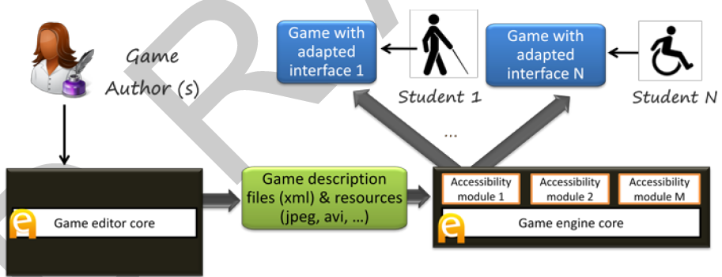
Game engine Core

…
Accessibility module 1
Accessibility module M
Game editor Core
Game description files and resources Core
Game Author

Game with adapted interface 1
Game with adapted interface N

Student 1
Student 2
Fig 3.1. Basic accessibility architecture. Accessibility was provided by specific input/output modules integrated with the engine, which are activated when the game was exported [8].
Command processing was directed by a regular grammar combined with a fixed list of synonyms for relevant verbs (actions) and nouns (interactive elements). The regular grammar was automatically generated from the description of the game, taking the actions defined for the interactive elements available in each game scenario [8].

Comparison Criteria

Goals of the Automation
The goal is to minimize the cost and effort needed for introducing accessibility in serious games. In accessibility architecture, accessibility was provided by specific input/output modules integrated with the engine, which are activated when the game was exported.

Foundation for Automation
In the case of 1994, all the adaptation to the user profile was performed automatically by analyzing the game description XML files and art resources. The regular grammar was automatically generated from the description of the game, taking the actions defined for the interactive elements available in each game scenario. (refer to table)

Pedagogical Foundation for the Automation
In this approach no pedagogical foundation method is used.

Validation Tool Support
No validation module has been implemented in this approach

Semiautomatic Adaptation - The case of "My first day at work"

Introduction

Another experiment which was resulted in the game "My first day at work", developed in collaboration with Technosite, a company of the ONCE (National Organization for the Blind in Spain) group. In Fig. 3.2, flexibility of the accessibility features was improved that now could be configured with the game editor.
In addition to the blind and motor disability profiles, a new user profile was considered: users with low vision. Colleagues from Technosite identified the adaptations this profile needed, which included screen and text magnification and use of a high contrast color scheme.
"My first day at work" was focused on meeting the needs of the three be-spoken profiles (blind, motor disability and low vision), it has been tried to make it accessible to users with cognitive disabilities (e.g. Down and Asperger syndromes) [8].

Game editore Core

……..
...
..

…
Additional description files (xml) + alternative resources
Game Author
Access config tool 1

Game engine Core

…
Game description files and resources Core
Accessibility module 1
Accessibility module M
Access config tool X
Game with adapted interface 1
Game with adapted interface N

Student 1
Student 2
Fig. 3.2. Improved architecture and workflow. The accessibility features are now configurable from the editor to match different user profiles. The editor also produces automatically additional description files and resources [8].
Dealing with these problems is much more complicated and there is little room for automation. The eAdventure adaptation engine was used to provide alternative paths in the game with different levels of difficulty, or alternative versions of text intensive components such as conversations.

Level of automatic and semi-automatic adaptation
Table 3.1 shows a summary of the adaptations performed. Adaptations related to the modality, how the user interacts with the game or perceives the game feedback are prone to be automated (e.g. interfaces for blind users and users with reduced mobility).
To make it accessible for users with low vision it was needed to produce alternative versions of 53 art resources, an increase of 7,57%. Although this value is not very high it could increase exponentially if more profiles were considered (e.g. users with color blindness), so it is important to keep the number of manually crafted alternative resources as low as possible [8].
Table 3.1. Summary of adaptations performed for each profile. Table reflects what aspect of the game were affected and the level of automation achieved [8].
Profile | Aspect | Adaption (s) | Automation
Blind | Interaction / modality | New interaction and adapted return of information | High
Motor disability | Interaction / modality | New Interaction | High
Low vision | Interface / rendering pipeline | High contrast rendering filters, magnification, alternative images and color schemes | Medium
Cognitive disability | Game design and content | Lessened difficulty of puzzles, alternative version of texts | Low

Comparison Criteria

Goals of the Automation
The goal is to minimize the cost and effort needed for introducing accessibility in serious games. In accessibility architecture, accessibility was provided by specific input/output modules integrated with the engine, which are activated when the game was exported.

Foundation for Automation
In the case of "My first day at work”, the accessibility features are now configurable from the editor to match different user profiles. The editor also produces automatically additional description files and resources. (refer to table)

Pedagogical Foundation for the Automation
In this approach no pedagogical foundation method is used.

Validation Tool Support
No validation module has been implemented in this approach.

Petri Nets for Representing Story Plots in Serious Games

Introduction
This part describes a novel technique for representing plots of stories in computer games and for unfolding stories according to these plots. The technique is based on Petri Nets. Its main advantages are: 1) it copes well with branching stories, which 2) can evolve in parallel in 3) large virtual worlds. While the issue of branching stories has been already studied in literature, the latter two issues have not been sufficiently addressed yet. The technique has been evaluated on a prototype implementation, and subsequently used in two serious games Europe 2045 and Karo. Europe 2045 is an on-line multi-player strategy game aimed at education of high-school students in economics, politics, and media studies, which is presently evaluated at high-schools in the Czech Republic. Karo is a storytelling simulation that is intended to engage students in decision making concerning social relations, and work on it still continues. While Europe 2045 simulates Europe in a coarse-grained way, Karo features a detailed virtual world inhabited by virtual humans. Besides presenting the Petri Nets modifications used in the prototype and in both of the games, the section details several scenarios from the games, and on a general level, it discusses the strengths and weaknesses of implementation of Petri Nets in virtual storytelling applications.
In this part, the different perspectives of a designer, who use Petri Nets as a specification tool, and a programmer, who use it as an architectural underpinning of the story manager, are emphasized.
Petri Nets is a specification technique frequently used in software engineering. A basic variant of it consists of containers (or places, represented by a circle), tokens (“the pellets”), actions (or transitions), and transition function. The containers contain the tokens. If a sufficient number of tokens is contained in specific containers, an action is triggered. After firing an action, the tokens that helped to fire this action are removed, and some new tokens are generated (see Fig. 3.3a). Which tokens fire which action and which action generates tokens to which containers is specified by the transition function (and depicted by arrows) [9].
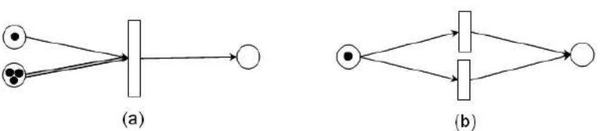
Figure 3.3: Petri Nets examples. a) The action generates one token if there is one token in the upper container and two in the lower container. b) The two actions are in conflict [9].

Petri Nets for Representation of Story Plots
For purposes of each particular storytelling application, it is beneficial to develop a particular modification that fits best for what the application demands.
First it’s described in detail a particular refinement of Petri Nets, based on so-called timed coloured Petri Nets. In fact, this refinement is used for prototyping purposes formerly, which allowed to conclude that Petri Nets are a fruitful technique in the storytelling domain.
To set the terminology, a PNA-model is the type of Petri Nets formalized in this section, and a PNA-plot is a specification of an individual plot by means of the PNA-model. Every PNA-plot can be loaded from an xml-file by an application called TEST that is developed, which features an abstract story manager for running and verifying PNA-plots. TEST works as follows: After a PNA-plot is loaded and the simulation started, events start to occur according to the PNA-plot in an abstract manner. That means that the TEST computes the story next function (1), but there is no simulator of a virtual world to compute the world next function (2). The result of this function is to be determined manually by a user through a check-box like interface in TEST; this mimics the changes that would be imposed on the world by the simulator or a user interacting with the world in case of a full-fledged application.

Europe 2045: Europe 2045 is an on-line multiplayer game aimed at education of high-school students in economics, politics, and media studies. The developmental phase is completed and the game is presently being evaluated.
The preliminary model was extended by presenting the PNB-model, which was used as a plot specification technique in the full-fledged serious game Europe 2045. Presently, this game features one 10-round, fully developed campaign, which comprises about 70 game events (affairs, or news items). This allows users to conclude that in this section, fruitfulness of Petri Nets is demonstrated in the domain of social-economical serious games.
The plot of the mentioned campaign was actually coded directly in PHP. This helped users to start quickly, but it also presents a limitation. To facilitate the development process, that is benefited from a graphical authoring tool, especially because it’s aimed at creating a second campaign and several undergraduate humanities students, who do not know PHP, develop other campaigns as a part of their university course. Developing this tool presents the future work.

Karo: Karo is a simulation featuring virtual humans intended as a serious game for civic. Particularly, it should help students to understand dynamic of social relationships. Presently,
it should be regarded as a research prototype, not a full-fledged application. Contrary to Europe 2045, programming work on Karo still continues.
In this part, the PNA-model was extended by presenting the PNC-model, which was used for developing a case-part scenario in Karo game. The main innovation in the
PNC-model is hierarchical nesting of Petri Nets. While this work is still in progress concerning its educational side and particularly the claims that “small influences can change the outcome of the story radically” and that this “has an educational potential”, the experience gained so far allows as to state that Petri Nets can be and in fact have been scaled for unfolding stories in an application featuring virtual humans.

Conclusion: In this section, it have described a method for specifying branching plots of scenarios that can evolve in parallel, i.e. in several different places at the same time. The method is specifically designed to cope with stories being unfolded in large virtual worlds.
While the PNB-model have demonstrated the practical usefulness of Petri Nets as a plot
representational technique in the domain of serious games, the PNC-model have showed
their scalability for an application featuring virtual humans. Apart from the ability to represent branching plots that can evolve in parallel, the strength of Petri Nets is that they are formal and yet can be presented graphically. It have found them as easily comprehensible by non-IT experts; not only the chief designer of Europe 2045 does not have IT background, but the technique was also explained to college students of humanities during a course (during about an hour and half) and they were subsequently able to use it to specify their own “toy” campaigns [9].

Comparison Criteria
Goals of the Automation
To set the terminology, a PNA-model is the type of Petri Nets formalized and a PNA-plot is a specification of an individual plot by means of the PNA-model. Every PNA-plot can be loaded from an xml-file by an application called TEST, which features an abstract story manager for running and verifying PNA-plots.

Foundation for Automation
The PNA-model features following entities: containers (which are places – “the circles”), tokens (which are “the pellets”), actions (which are transitions –“the rectangles”) and triggers (more or less, they correspond to a transition function to “the arrows”). The purpose of a trigger is to fire an action according to tokens’ location, or to add or to remove tokens from containers.

Pedagogical Foundation for the Automation
“Interactive–narrative” tension was solved by limiting the degree of interactivity available to a user. It was allowed the user to participate only by changing emotions, moods, and relationships of the characters, and by modifying the environment slightly, e.g. by moving objects.

Validation Tool Support
The fruitfulness of Petri Nets was evaluated in storytelling in general. The evaluation took place on the application TEST that allowed for running PNA-plots in an abstract manner, i.e. without any virtual world connected to it.

Applying Cellular Automata and DEVS Methodologies to Digital Games

Introduction
The purpose of this section is to survey how cellular automata and its variant, called cell-DEVS (discrete-event systems specifications), may be used to implement computer simulations that can be used as digital serious games. The implementation is illustrated that through some of the practical applications of such cellular automata.
A cellular automaton is a very simple abstraction invented to part self-reproducing systems. Since then, cellular automata (CA) have been widely used to reproduce and better understand the dynamics of complex phenomena found in the real world, especially when these phenomena only require very simple programming to be reproduced digitally. In this part, an extension of the CA is described that compensates for this missing structure by means of another simple but equally powerful mathematical abstraction called discrete-event systems specifications (DEVS).
Cellular models and DEVS can provide enhanced capabilities in the development of serious games applications. In this section, it will be given different examples in this field. The idea of this section is to show how CA and DEVS models can be used to create varied serious games samples, focusing on the methods and techniques employed in developing those models.
In this section, it will be introduced different cellular models applications with the goal of answering the questions above. These varied models have been developed and simulated with the CD++ environment, and they illustrate the potential of applying CA and DEVS-based methodologies in serious game development [10].

A Simple Model of Bouncing Balls: In this section, the basic definitions of Cell-DEVS models are shown by defining the behavior of balls bouncing within a container. The model is specified by a 20 × 20 cell space using the CD++ specification language. The model defines nine sets of rules to control the movement of balls, including four sets of rules for the corner and border cells each as well as a set of rules for the rest of the cell space.
Psection Collision:This model uses a lattice gas to define a 2D cellular model of the collision of psections. This kind of model can be used to part the psection collision of gas fluids, where different types of fluids are mixed together in a container. Each cell uses a double value that consists of an integer part and a fraction part. The integer part represents four possible moving directions of a psection (1:E, 2:N, 3:W, 4: S), whereas the fraction part represents the purity of the fluid. The collision of two psections modifies not only their direction but also the degree of purity of the corresponding fluids.
Gossip Propagation: This model represents the propagation of a piece of gossip (or information) by a group of people, using the flow of information from a single source to a group of sinks (i.e., receivers). The information only propagates to interested parties from someone who has already heard the gossip.
The Cell-DEVS model of this gossip propagation uses two bidimensional square grids. The bottom layer grid represents the people, who will be either active or passive based on whether or not they know the gossip. The second layer is used to hold the probabilities of spreading the gossip. The cell neighborhood can be either a Moore or a von Neumann neighborhood (i.e., the cells to the N/S/E/W). Each cell in the inverse neighborhood has a random chance of being told the gossip from a cell that knows it. This prevents the model from evolving the same way in every execution. This random number is obtained from the layer above. This model is defined by the three following rules for cells:
1. If a cell is passive, and cells are active in its inverse neighborhood, the cell may become active.
2. If a cell is active, it will remain active.
3. A cell that knows the gossip is unlikely to forget it.
Human Behavior at a Metro Station: This model represents the movement of persons waiting for a train in a metro station. As more people arrive, they tend to concentrate at the two boarding doors. Two groups of people are formed around the boarding doors at the border of the platform waiting for the doors to open. When the train arrives, the people leaving the train have a higher priority than those trying to get into the train. Therefore, if someone is leaving the train, the people waiting at the platform start to move to let them leave. In the same way, collision detection is used such that if people try to get into the train at the same time, only one of them gets the access [10].
Voters: In this game, it’s represented how voters’ political preferences are influenced by others in a constrained environment using a 2D cellular model. The voters can either stick to their current political preferences or change their preferences based on the influence of their neighbors. Each cell stands for a voter who is under the influence of four neighbors as defined by a Von Neumann’s neighborhood. The rules that control future political preference have two parts:
(a) voters stick to their previous political preference according to a global probability
parameter (e.g., 50%) and (b) if the voter decides to change the political preference, one of the four adjacent neighbors is picked randomly with equal probability (i.e., 25%) and this neighbor’s current preference value is assigned to the voter.
The Daisy World: The Daisy World model is a game that can be used to part the principle of self-regulation and the effect of planetary life on climate change. An imaginary planet, called the Daisy World, is populated solely by black and white daisies. Black daisies warm up the planet by absorbing heat, while white daisies cool it by reflecting heat. As the planet’s sun warms up, the daisies maintain a moderate temperature by altering the balance between the black and white. Eventually, as the sun gets too hot, no daisy can survive and all life dies out on the planet.
Sandpile Modeling: CA models have been used to part the formation of sand piles in the event of landslides caused by major. Here, it’s shown the definition of one of such CA proposed in, built as a coupled model consisting of a cellular model component (representing and a DEVS atomic component that serves as a sand generator.
3D Free-Form Shape Modeling: 3D free-form shape modeling has been used in various applications such as computeraided design systems and mechanical engineering. However, modeling free-form shapes in 3D space involves considerable computation based on simplified physical laws. In this section, it will be shown how to apply cellular models for the compression (from outside) and deformation (from inside) of a virtual clay model.
The deformation process is the result of clay transportation from high-density areas to low-density areas. In the cellular model, each cell has a positive value corresponding to the mass of clay contained in the cell. A cell with value above a predefined threshold will transfer clay to its neighboring cells. The model defines a Margolus neighborhood for the cells. The 2D Margolus neighborhood is a block that includes the nearest four cells. Cells belonging to the same block will perform state transitions together at each step. In addition, block boundaries change depending on whether the transition is performed at an odd or even step. Hence, the neighborhood of each cell alternates between its odd and even configuration at every transition step.
Each cell has a binary state reflecting whether it has a mass of clay above or under the threshold, creating four different block patterns of clay transitions in the 2D neighborhood. The block patterns are more complex in the 3D Margolus neighborhood, including 21 different transition rules.
In this part, it was surveyed how DEVS and its cell-DEVS variant can be used to implement CA in computer simulations. In particular, the multiple was emphasized benefits of using a DEVS approach for the development of serious games. Because of its rigorous formalization and continuing standardization, DEVS favors content sharing and interoperability in the development of serious game applications. In addition, DEVS also makes it easier to realize virtual world evolution in the simulations, thanks to its modular model construction capability and explicit separation of business logic (models) and simulation implementation. As DEVS is based on the discrete-event simulation paradigm, it allows for improving the efficiency of terrain generation without losing accuracy. Finally, DEVS-based simulations can be transparently executed in parallel and distributed computing environments by taking advantage of advanced PADS techniques; it can help reduce the simulation time significantly at reduced cost [10].
Also, in this part, it was illustrated some of the practical examples that make use of such cellular models in Serious Games applications, ranging from simple ones such as the bouncing ball to more sophisticated ones such as crowd behavior and 3D shape deformation. The variety of these use cases demonstrates the potential of using DEVSbased cellular M&S for parting real-world systems, situations, or phenomena. It also demonstrates how such models can be easily expressed using simple constructions and rules. The ability to express a given model at ease is a clear invitation to experiment with new models and to discover that simple local rules are often sufficient to explain the most complex and sometimes counterintuitive phenomenon observed in the real world [10].

Comparison Criteria

Goals of the Automation
The purpose of this section was to survey how cellular automata and its variant, called cell-DEVS, may be used to implement computer simulations that can be used as digital serious games.
Foundation for Automation
The varied models have been developed and simulated with the CD++ environment, and they illustrate the potential of applying CA and DEVS-based methodologies in serious game development.

Pedagogical Foundation for the Automation
The fundamental idea behind this CA model is to use a network of identical elements, named cells, each having its own individual state and sharing the same set of transition (evolutionary) rules. The transition rules decide the next state of a cell based on its current state and the current state of its neighboring cells in the network; rules are applied synchronously to every cell of the network. Hence, the resulting cellular automaton evolves step by step, and each such evolution is called a generation.

Validation Tool Support
No validation module has been implemented in this approach.

Entertainment Games

Toward Supporting Stories with Procedurally Generated Game Worlds

Introduction
Computer role playing games engage players through interleaved story and open-ended game play. It’s presented an approach to procedurally generating, rendering, and making playable novel games based on a priori unknown story structures. These stories may be authored by humans or by computational story generation systems. the approach couples player, designer, and algorithm to generate a novel game using preferences for game play style, general design aesthetics, and a novel story structure. the approach is implemented in GAME FORGE, a system that uses search-based optimization to find and render a novel game world configuration that supports a sequence of plot points plus play style preferences. Additionally, GAME FORGE supports execution of the game through reactive control of game world logic and non-player character behavior.
It’ solved the problem of automatically designing, building, and rendering a completely functional game world for a story. Recall that CRPGs interleave plot points and open-ended game play; the game world to be generated must ensure a coherent sequence of plot points are encountered in the world. In the process of generating the world, the approach also attempts to incorporate preferences for game play style into the configuration of the world. The problem can be specified as follows: given a list of plot points of known types, referencing locations of known types, generate a game world that allows a linear progression through the plot points and supports user play style preferences. GAME FORGE is specifically targeted to CRPGs, but demonstrates how other heavily story dependent game genres can be supported. To map from story to space, GAME FORGE utilizes a metaphor of islands and bridges. Islands are areas where critical plot points occur. Each event in the plot is associated with a location [11].
The game world generator parses the generated plot and extracts a sequence of locations, each of which becomes an island. The generation of the game world environment is treated as an optimization process, balancing two competing sets of requirements:
Game world model: Captures the designer-specified believable transitions between environment types as the player moves through the game world. 2) Player model: Captures player-indicated play style preferences.
GAME FORGE generates the game world through the use of a genetic algorithm (GA) guided by a fitness function incorporating the above requirements.
Genotype Representation: a game world genotype is shown as a space tree, a tree data structure in which each node represents a portion of the world.
Fitness Function: it’s employed evaluation criteria based on a game world model and player model. The game world model constrains generation to more natural worlds, while the player model guides generation towards the expressed preferences of a given player. The game world model evaluates the adjacency of environment types along bridges and islands based on an environment transition graph, in which nodes specify types of environments and links indicate the designer-specified probability for two environment types to be adjacent.
Genetic Algorithm Implementation: the GA starts with an initial population of randomly generated candidate space trees; each is created from a list of islands and pseudo-randomly constructed bridges between each adjacent pair of islands based on the player model and world model. the GA halts when any individual’s fitness is less than a given percentage of the total theoretical possible penalty. To perform a mutation, it’s randomly choosen a node in the given candidate tree to mutate. The possible mutations are: 1) Addition, 2) Deletion, 3) Environment Type Change

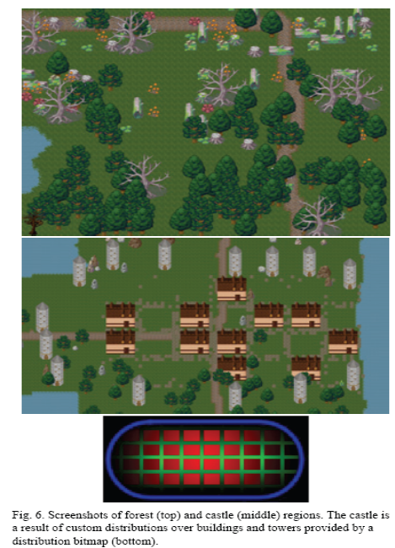
Fig. 3.4. Screenshots of forest (top) and castle (middle) regions. The castle is a result of custom distributions
over buildings and towers provided by a distribution bitmap (bottom) [11].

Figure 3.4. shows examples of the population of different types of environments. The top image shows a forest environment type, populated by a Gaussian distribution; note the blending of decorations from the adjacent swamp above this forest. The middle and bottom images show a castle environment type and the custom distribution bitmap used to generate it; the distribution of buildings is in red, towers in blue, and pavement stones in green.
STORY EXECUTION: After construction of the game world, the game must be playable without further modification by the user. There are two issues that must be addressed: (a) the world must be populated with NPCs, and (b) the NPCs must act out the story, which was not known prior to execution. In the current system, avatars are simple animated sprites. a simple, easily extensible meta-data map is chosen from symbolic descriptors to art assets [11].

Comparison Criteria

Goals of the Automation
As a consequence of their content-heavy nature, CRPGs are prime candidates for the application of Procedural Content Generation (PCG).Plot points are parameterized to account for different narrative needs. When plot points execute, they pass their parameters on to the reactive scripts. These parameters not only determine which NPC or item performs the associated behavior, but also instigate traversals through the appropriate branches of the ABL behavior tree.

Foundation for Automation
The GA starts with an initial population of randomly generated candidate space trees; each is created from a list of islands and pseudo-randomly constructed bridges between each adjacent pair of islands based on the player model and world model. The GA halts when any individual’s fitness is less than a given percentage of the total theoretical possible penalty.
The GA also halts if more than 100 generations pass without significant improvement of the fitness of the best space tree. To perform a mutation, a node is chosen in the given candidate tree to mutate. The possible mutations are: Addition, Deletion, Environment Type Change.

Pedagogical Foundation for the Automation
As it can be seen, no Pedagogical Foundation for the Automation is used.

Validation Tool Support
It’s employed evaluation criteria based on a game world model and player model. The game world model constrains generation to more natural worlds, while the player model guides generation towards the expressed preferences of a given player.

Modeling Player Experience for Content Creation

Introduction
In this part, it’s used computational intelligence techniques to built quantitative models of player experience for a platform game. The models accurately predict certain key affective states of the player based on both gameplay metrics that relate to the actions performed by the player in the game, and on parameters of the level that was played. For the experiments presented here, a version of the classic Super Mario Bros game is enhanced with parameterizable level generation and gameplay metrics collection.
Player pairwise preference data is collected using forced choice questionnaires, and the models are trained using this data and neuroevolutionary preference learning of multilayer perceptions (MLPs). The derived models will be used to optimize design parameters for particular types of player experience, allowing the designer to automatically generate unique levels that induce the desired experience for the player.

Modeling of player experience are considered as a whole to be of utmost importance for making automatic content generation techniques more sophisticated and usable. The work was described in this part is novel in that computational models of player experience are constructed which are derived from gameplay interaction and can be used as fitness functions for game content generation. For that purpose, it’s been used a modified version of a classic platform game for the experiments and collect player data through the Internet.
This part significantly extends in which the core ideas of the methodology proposed are outlined and, in which only three affective states are analyzed and only using single-layer perceptions (SLPs) and less sophisticated feature selection.
The focus and main contribution of this part is introducing a refined method for player experience modeling, and exemplifying how it can be used for a well-known game. The particular models are only meant to be valid for this game, and possibly closely related games, whereas the method could be generalized to games in many different genres as well as for modeling the experience of user–computer interaction in general [12].

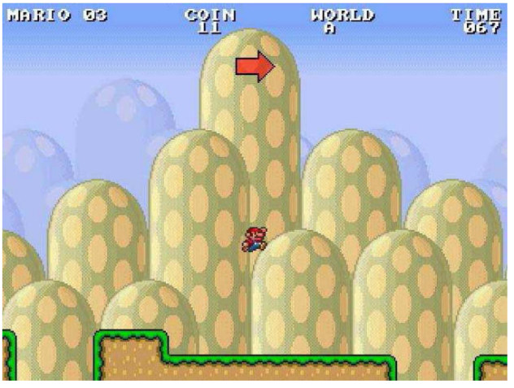
Fig 3.5.Testbed game screenshot, showing small Mario jumping over a piece
of flat terrain surrounded by two gaps [12].

MODELING OF PLAYER EXPERIENCE PREFERENCES
This section presents the two-phase procedure followed towards modeling player experience. The ultimate aim of this part is to control for level generation based on player experience. On that basis, it is desired that level features and game mechanics are adjusted dynamically so that the player experience (output value of MLPs) is optimized.
For that purpose, all four controllable features (if not already selected from the first phase) are forced into the input vector of the MLP which includes the feature subset selected via the SLP modeling procedure. The rationale behind this two-phase approach is threefold: 1) Expressiveness of SLP models. 2) Computational effort 3) Representation completeness

A. SLP Models: Feature Selection
The correlations calculated above provide linear relationships between individual features and reported emotions. However, these relationships are most likely more complex than can be captured by linear models. All evolved networks performed much better than networks with random weights, which reached chance level prediction accuracy. As a general observation, sequential forward selection appears to be the most appropriate feature selection mechanism for all six emotions. SFS develops feature subsets that feed SLP models which achieve the highest cross-validation performance.
Even though SFFS is a more efficient hill climber which allows backward search it does not showcase that advantage in small feature sets (e.g., less than eight features) as the ones examined in this part. Note that SFFS performance is different from SFS performance only in challenge prediction since two backward steps occurred during that run; no successful backward step was performed in any other affective state predicted resulting in equal performance values for SFS and SFFS. SLP predictors of each affective state are Fun and Challenge.
B. MLP Models: Optimizing Topology
In particular, reported fun, challenge, frustration, predictability, anxiety, and boredom were approximated with respective accuracies of 69.18%, 77.77%, 88.66%, 76.28%, 70.63%, and 60.87% using SFS as the feature selection mechanism.
All remaining controllable parameters which are not included in the selected feature subset are forced into the input of MLP (rather than SLP) models of emotional preferences and their topologies are optimized for maximum prediction accuracy. MLPs have the advantage of universal approximation capacity; in particular, combinatorial relationships (such as XOR) can be represented.
MLP topologies of two hidden layers, with up to 30 and ten hidden neurons, respectively, in the first and second layers are investigated; this sums to 330 different topologies which are tested for each input vector (feature set selected from SLPs plus the remaining controllable features). In general, it is worth noticing that the networks have a wide variety of sizes: from the relatively small networks of fun and challenge, to the moderate-sized MLPs of predictability and anxiety, to the large MLPs of frustration and boredom. Independently of size, all MLP models exhibit an improvement in their performance compared to the corresponding SLP models .The best topology found for each affective state varies a lot across all six emotions showcasing, in part, the complexity of predicting the preferences of users for each affective state individually.

The work reported in this part introduces data-driven computational models that predict several dimensions of player experience based on both level design features and gameplay metrics. The work also constitutes the first player experience part in the context of a platform game; follow-up experiments will be the first where game levels are generated based on quantitative player experience models. While the experiments were successful in the sense that the predictors achieved high accuracy on core aspects of player experience using threefold cross validation, there are potentially ways to further increase those models’ performance. As noted above, gathering data from more gameplay sessions could assist in the process of improving these cognitive models of player experience. However, given the challenges of accurately capturing the user’s affective state reported in the literature [12].

Comparison Criteria

Goals of the Automation
A modified version of a classic platform game was used for the experiments and player data was collected through the Internet. The content generation could also be part of the game and done online, serving players new game content such as levels and game modes based on how they individually have played previous levels. At the extreme of online content creation, levels could be modified in real time by, e.g., removing or adding enemies, obstacles, shortcuts, items, etc.

Foundation for Automation
A generational genetic algorithm (GA) was implemented, using a fitness function that measures the difference between the subject’s reported emotional preferences and the relative magnitude of the corresponding model (ANN) output. More specifically, the logistic (sigmoidal) function 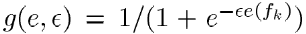is used where 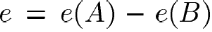is the difference of the ANN output values (investigated emotion/affective state) between game A and game B ; if A > B and if A < B. Both the sigmoidal shape of the objective function and its selected values are inspired by its successful application as a fitness function in neuroevolution preference learning problems.

Pedagogical Foundation for the Automation
No pedagogical has been used in this approach.

Validation Tool Support
The performance of each user model is measured through the average classification accuracy of the model in three independent runs using the threefold cross-validation technique on the three possible independent training and validation data sets.

Towards Automated Game Design

Introduction
In this section, it is described an approach to formalizing game mechanics and generating games using those mechanics, using WordNet and ConceptNet to assist in performing common-sense reasoning about game verbs and nouns. Also it’s demonstrated and described in detail a prototype that designs micro-games in the style of Nintendo's WarioWare series. For WarioWare-style generator, it has been chosen to focus on theme as the guiding aspect. Design goals are specified in terms of nouns and verbs; the generator's job is to create micro-games that are \about the verb and/or noun. Since a micro-game instantiates a single, atomic game mechanic, and maps real-world referents onto this mechanic, such games are a nice vehicle for exploring the common-sense reasoning issues that arise in the thematic aspect of game design.

Generating WarioWare-style games
Although WarioWare-style micro-games are quite simple structurally, usually containing one or two pieces of abstract mechanics and lasting for no more than a few seconds, they are an example of a game style that actual game designers work on and release commercially (rather than an artificial toy domain), with a design space that touches on a wide cross-section of issues in game design. Their abstract simplicity allows users to focus on the thematic elements of game generation, and the fact that they are lightweight games that are easy and quick to play meshes well with a number of potential applications, such as web-distributed casual games and customized cell-phone games [13].

Common-sense thematic content
Generating a game that fulfills the request is now a combination of two common-sense problems: The game should \make sense" in terms of the roles its thematic elements are playing, and it should be \reasonably close" to what the user requested. To address both problems, it’s used a combination of the ConceptNet and WordNet knowledge bases. ConceptNet is a graph-structured common-sense knowledge base mined from OpenMind a collection of semi-structured English sentences expressing common-sense facts gathered from online volunteers. ConceptNet's nodes are English words or phrases, and links between them express semantic relationships such as (CapableOf "person" "play video game"). WordNet is a similarly graph-structured knowledge base (Concept-Net's structure was based on WordNet's), but it positions itself as a dictionary rather than as a semantic knowledge base. Nonetheless, it contains semantic information in the form of word hierarchies, where a word below another one in the hierarchy is a specialization of the higher-up one (the higher word is a \hypernym", and the lower one a \hyponym" if a noun, or \troponym" if a verb).
This information add inheritance to ConceptNet queries: If something is true of animals in general, then it is true for specific kinds of animals as well. Since ConceptNet knows that an animal can be shot, WordNet-based inheritance lets users figure out that a pheasant, as a specific kind of animal, can also be shot. In addition to using WordNet to extend ConceptNet's coverage, its hypernymy relationships is used to determine simple attributes, such as whether a noun is animate (if it is, it will be below \animate thing" in the hierarchy). Finally, distances between nouns and verbs are been used in WordNet and ConceptNet, respectively, as simple measures of similarity: WordNet for nouns (due to its fairly comprehensive taxonomy) and ConceptNet for verbs (since this captures more complex notions of similarity such as \can operate on the same object). While link distance is a simple notion of similarity, it has worked well as a first approximation [13].

Decomposing WarioWare
To facilitate generation, a number of styles of WarioWare games are abstracted into abstract game types; currently the system knows about three of them. An Avoid game is one in which one entity, the \avoider", must avoid (for the duration of the game) one or more other entities, the \attackers", which may attack the avoider either directly or via other objects. The player can play either role. An Acquir game is one in which the player must find an object within a time limit. A Fill game is one in which the player must fill a meter within a time limit. These abstract game types capture the abstract mechanics the system currently knows about. These game types can be implemented via several stock sets of concrete game mechanics, represented in a mixable J2ME (Java mobile platform) class library like Dodger game, Shooter game ,Pick-Up , Pump game and Move game.

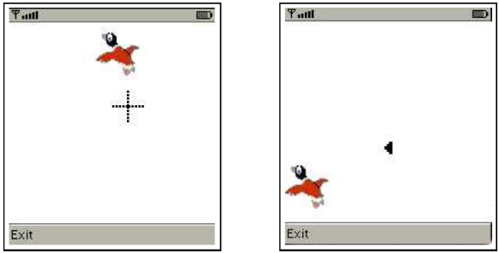
Fig 3.6. Two games generated for the noun \pheasant" and verb \shoot". A duck is in both since it is the closest noun to \pheasant" for which the generator has a sprite. Both are Avoid games with Attacker-verb \shoot", Avoider-noun \duck", and Attacker-noun \bullet". The left game is implemented by the Shooter concrete mechanic and has the player trying to shoot the duck; the right game is implemented by the Dodger concrete mechanic and has the player, as the duck, trying to avoid bullets [13].

These concrete game mechanics capture the concrete representations and control mappings the system currently knows about. Finally, there is a stock set of sprites, each attached to a noun describing them, that can be used as the graphical representation of any of the objects in any of the games. The end result of the generation process is a recipe for building a game. The game is then built out of the composable classes corresponding to the five sets of stock concrete mechanics (plus input and movement-control classes) to produce a running game. Screenshots of the realizations of two generated games are shown in Figure 3.6.

Common-sense WarioWare generation
In response to a request, a number of games are generated to meet a set of constraints on what games \make sense" in each of the three types of abstract games, and are scored according to a heuristic measure of how \reasonably close" they are to the player's actual request. These games are then built and fed to the player in rapid-fire sequence, much as in Nintendo's original WarioWare, with the games growing increasingly distant from the original request as the system has to stretch further to find games satisfying the thematic request that it hasn't yet used. The original verb, not the prototype, is then used to determine which nouns can be mapped into the game.

Automated game generation is a little-explored area of research that holds great potential, both as a technique that would enable the development of new types of games, and as a research agenda that tackles the problem of machine creativity from the perspective of the generation of highly interactive artifacts. It was described a general framework for viewing this problem, and a prototype system that generates games in the style of WarioWare about user-requested subjects, while respecting common-sense expectations about the roles of verbs and nouns in those games [13].

Comparison Criteria
Goals of the Automation
An approach was described to formalizing game mechanics and generating games using those mechanics, using WordNet and ConceptNet to assist in performing common-sense reasoning about game verbs and nouns.

Foundation for Automation
It’s used a combination of the ConceptNet and WordNet knowledge bases. ConceptNet is a graph-structured common-sense knowledge base mined from OpenMind a collection of semi-structured English sentences expressing common-sense facts gathered from online volunteers. ConceptNet's nodes are English words or phrases, and links between them express semantic relationships such as (CapableOf "person" "play video game"). WordNet is a similarly graph-structured knowledge base (Concept-Net's structure was based on WordNet's), but it positions itself as a dictionary rather than as a semantic knowledge base. Nonetheless, it contains semantic information in the form of word hierarchies, where a word below another one in the hierarchy is a specialization of the higher-up one (the higher word is a \hypernym", and the lower one a \hyponym" if a noun, or \troponym" if a verb).

Pedagogical Foundation for the Automation
In this approach no pedagogical foundation method is used.

Validation Tool Support
No validation module has been implemented in this approach.

User-preference-based automated level generation for platform games

Introduction
In this work, following successes in learning and using user preferences in other areas, it will be presented an automated level generation method for the game of the Mario AI competition. The method learns the preferences for various features that the user/player currently has, based on having the user play a few short given levels and answering a few questions. The testbed is extended to allow for more feature variations and create levels in a three step process. First a graph is created to represent the future cells for the game that fulfills constraints created out of the observed feature preferences (and the answers to the questions) of the user. This graph is then transformed into a two dimensional level for the game keeping the cell connections from the graph. Finally, the individual cell contents are created, again using constraints and preferences observed from the user (and the user’s answers). The user preferences from four players with different skills and genre preferences are collected. The levels created for each of the players show substantial differences, aligning them with the collected player expectations.

OUR APPROACH TO LEVEL GENERATION
The Mario AI platform game has the human player navigate through a world of platforms, holes between platforms, portals connecting different parts of a level (essentially being teleporters), and enemies, like “Goombas” and “Spiked Turtles”. The player character has to jump from platform to platform or on enemies (to kill them) to pass through a level. The player character can make use of “special effects”, like shells and fireballs, and can also collect coins.
A high-level view on level generation: In general, the approach consists of two phases, the user preference elicitation and the level generation based on preference parameters. The latter phase consists of three steps, namely creating a cell graph, conversion of the graph into a grid, and finally creating the individual cells making sure that they fit the grid. The second phase can be performed several times using the results from the first phase due to the use of some randomness in the three steps of the second phase [14].
A combination of multiple choice questions and player performance in short pre-defined levels are used to get an idea of what kind of level the user would like to play. Two multiple choice questions ask the user about their preferred level of difficulty, and their opinion on different kinds of challenges. The user then plays three pre-defined levels, both to measure their skill level, and to verify the answers provided to the questions. While the user plays the predefined levels a variety of player behaviors are counted, which then are compacted into metrics. Using these metrics allows to determine four basic parameter values for the player, which are then used during the level generation phase. For realizing the second phase, level generation process will be started by creating a directed graph, which describes the number of cells, and which cells may be accessed from other cells. The structure of this graph will control the large scale complexity of the level, including how often the player’s path may diverge and force the player to make a choice, and how much of the content will remain unseen by the player if the most direct route from start to finish is chosen. Figure 3.7 presents an example of such a graph, with the box indicating the shortest path from start to finish.

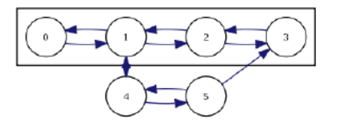
Fig. 3.7: A sample graph [14].

In the next step, the graph must be converted into a grid representation, which will decide the geographical size and location of each cell. Without the use of a portal system, this conversion is difficult and sometimes impossible. In the final step, content is generated for each cell separately, then assembled into a full level according to the requirements represented by the grid.
Eliciting user preferences: In order to create a level that represents the current preferences of a player, it’s started by asking the player two pre-game questions. The first lets the player indicate one of three sub-genres of the general game, namely Combat, Flow, and Puzzle. The second question asks the player to indicate a difficulty level. The player’s self-evaluation is confirmed by a set of trials used to measure the player’s abilities in a variety of common situations. These trials are static hand-made levels, which are shorter than a typical level but of much greater difficulty.
Graph Generation: The first step in actually creating a level using the method is to create a graph representing a given number, namely 8·puzzle+7, of cells (as nodes) and the intended connections between those cells. For a graph to be acceptable (feasible) for the next steps, irt’s required it to fulfill a set of given (feasibility) constraints. This still leaves quite a number of possible graphs and in order to create a “good” graph, a feasible-infeasible two-population genetic algorithm are used to search for a graph that is “good” with regard to a given fitness function.
Grid Generation: The best (feasible) individual (graph) found by the genetic algorithm from the last step is used as the input to the second step of the method, the grid generation step. Since there are usually several different possibilities where a cell can be placed in the grid, the grid generation is essentially an or-tree based search. At any given depth in this search tree, the next cell to be added is the cell named at the same depth in the placement order.
Cell Content Generation: With the grid created by the last step, the remaining task is to fill the cells in the grid with content. The candidate cell is then created as a copy of the parent cell, with the new component added in an appropriate position. Cells are scored based on quantities derived from an accessibility graph which describes the available paths that a player and enemies may take through the level. It is generated by coarse-grained traversal of the level (equating possible positions with entire blocks).

EVALUATION: the level generation method aims at creating a level for a particular person respecting the current moods and wishes of this person. Therefore it has been chosen a show-and-telllike approach to evaluate the method. The speed with which a player moves indicates experience with the game, particularly with the flow aspect. Users who moved slower, covered less ground and killed fewer enemies, the clutter rating has been increased. As with coins, holes will appear in every level regardless of supplied parameters. What does vary with respect to flow is the size and frequency of these holes. In Figure 3.8a, holes are nearly everywhere except where they would allow a “shortcut” between two cells which are intended to be separate.
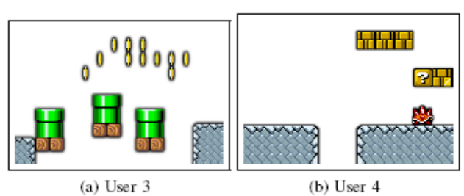
Figure 3.8: Extreme cases with respect to flow [14].

A method is presented for creating levels for platform games based on eliciting the preferences of a particular player and allowing for different subgenres of platform games. The three step process of creating levels allows for making use of the player preferences on different levels of abstraction and also allows for focusing the search on particular aspects of the game only, which – together with appropriate constraints – keeps the search spaces manageable. In the evaluations, the created levels reflected the wishes of the players they were created for [14].

Comparison Criteria
Goals of the Automation
In this work, following successes in learning and using user preferences in other areas, it will be presented an automated level generation method for the game of the Mario AI competition. The method learns the preferences for various features that the user/player currently has, based on having the user play a few short given levels and answering a few questions.
The individual cell contents are created, using constraints and preferences observed from the user (and the user’s answers).

Foundation for Automation
The fitness function evaluates the individuals and is a weighted sum of the following four measures: Average Outgoing Edges - EO(),Start Node Connections - ES(),Start Node Connections - ES(), End Node Connections - EE(),Path Length - L().Then the total fitness of a level graph x is evaluated as: F(x) = w1 ·EO(x) + w2 ·ES(x) + w3 ·EE(x) + w4 ·L(x)
As stated above, only feasible graphs can be used in the following steps of the level generation method. Feasibility is defined by fulfilling the following constraints: Path Length - CL(),Forward Reachability - CF (),Backward Reachability - CB(). With these constraints, every graph x, for which the expression: C(x) = CL(x) ^ CF (x) ^ CB(x)
The best (feasible) individual (graph) found by the genetic algorithm from the last step is used as the input to the second step of the method, the grid generation step. With the grid created by the last step, the remaining task is to fill the cells in the grid with content.

Pedagogical Foundation for the Automation
In order to create a level that represents the current preferences of a player, it’s started by asking the player two pre-game questions. The first lets the player indicate one of three sub-genres of the general game, namely Combat, Flow, and Puzzle. The second question asks the player to indicate a difficulty level. The player’s self-evaluation is confirmed by a set of trials used to measure the player’s abilities in a variety of common situations. These trials are static hand-made levels, which are shorter than a typical level but of much greater difficulty.

Validation Tool Support
In the evaluation, the user preferences from four players was collected with different skills and genre preferences. The fitness function evaluates the individuals and is a weighted sum of the following four measures: Average Outgoing Edges - EO(), Start Node Connections - ES(), End Node Connections - EE(), Path Length - L(). In the evaluations, the created levels reflected the wishes of the players they were created for.

An Offline Planning Approach to Game Plotline Adaptation

Introduction
Role-playing games, and other types of contemporary video games, usually contain a main storyline consisting of several causally related quests. As players have different motivations, tastes and preferences, it can be beneficial to customize game plotlines. In this section, an offline algorithm for adapting human-authored game plotlines for computer role-playing games will be presented to suit the unique needs of individual players, thereby customizing gaming experiences and enhancing re-playability. On-demand entertainment refers to the possibility that one can, at any time, request an entertainment experience that is significantly different from those previously consumed. In addition, entertainment artifacts should be customized or configured to suit every player’s unique motivation, tastes, history and ability. This section addresses on-demand and customized entertainment in the context of generating plotlines for role-playing games.
The contribution of this section is a system that solves the plotline adaptation problem: Given a complete, human-authored plotline consisting of sequence of quests, a library of quest structures, and a set of requirements about what an optimal gameplay experience should be for a particular user at a particular time, produce a sound, coherent variation that meets the requirements while retaining as much of the original plotline as possible. Offline processing affords the possibility to making globally optimal decisions about plotline structures, complimenting online adaptation techniques known as interactive storytelling. The supposed technique is justified with a discussion on theoretical authoring gains and empirical evaluation of the algorithm [15].

The Architecture of the Proposed System

Game Plot Adaptation
Figure 3.9 shows the adaptation pipeline for game plotlines. The game adaptation process takes a main plotline, a library of quest structures, and a set of player requirements as input. A player model generates a set of requirements, based on the player’s preferences, history, and a model of novelty. Importantly, the cycle between player and adaptation implies that games can be changed after each time it is played, thereby increasing its replayability. Possible actions in the virtual world are known to the system.
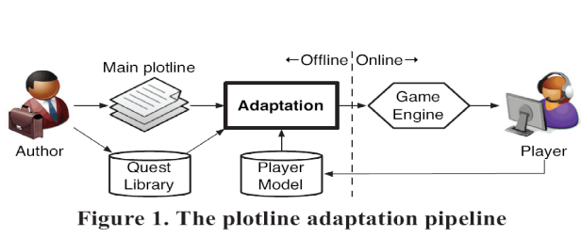
Figure 3.9. the plotline adaption pipeline [15]

Plot Representation
Following others, the plan-like representations of narrative are employed because they capture causality and temporality of action and provide a formal framework built on first principles, such as soundness and coherence, for selecting and ordering events. However, unlike a plan meant for execution, it’s used plans as descriptions of events expected to unfold in a virtual world. Each action represents a formal declaration of an event that can be performed by the player or non-player characters, or occurs as a consequence of physics laws in the virtual world.
The specific representation builds on partial-order plans. In this system, quests are represented as top-level abstract events. A quest has a single effect, guest complete (guest-X), and may or may not have any preconditions. Figure 3.10 shows a complete plotline consisting of two quests. Primitive actions are shown as solid rectangles and abstract actions are shown as rounded rectangles. The hierarchical relationship between events is reflected in the containment relationships of rectangles.
A coherent narrative is one in which, in the DAG formed by events and causal links, there is a path from each event to a significant outcome. Any event that is not part of some path to the outcome situation is referred to as a dead end.

Player Model
The player's preferences are modeled as a function of previously selected quests. Each quest, in turn, is represented as a feature vector in a semantic space. A technique is utilized to determine preferences over quests via ratings after gameplay concludes. In addition, a novelty model favors quests that are appropriately novel to the player based on his or her history so that he or she would be neither bored nor unpleasantly surprised. Computing a weighted sum of utility by preference and utility by novelty, the result is the selection of the k quests with the greatest utility that should be included in the game plotline.

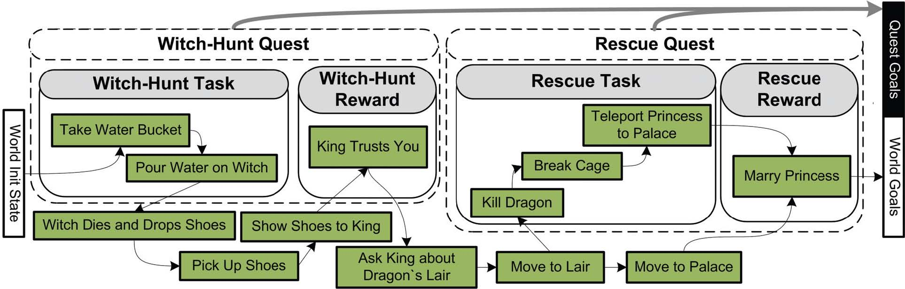
Figure 3.10. Original game plotline before adaptation [15]

Adaptation Algorithm

The plot adaptation module receives as input the following components:

- A complete plotline – a partially ordered, hierarchical plan – composed of events within and outside of quests.
- A set of plot requirements: guest complete (guest-X) propositions specifying what quests should be included, and corresponding world-level outcome propositions.

The adaptation algorithm is shown in Figure 3.11. The main loop is the standard plan refinement search loop.

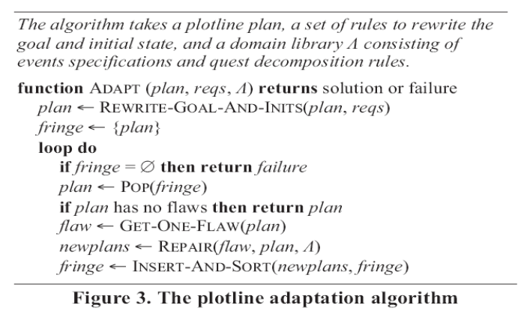
Figure 3.11. the plotline adaption algorithm [15]

Plotline adaptation scales up the ability to deliver customized experiences without significantly increasing the authoring effort. The variability is focused– the number of distinct stories – as the metric.
A one-time authoring cost by a domain engineer is incurred in the development of a world domain model, containing specifications for primitive events, abstract events (including quests), and decomposition rules. The payoff is a theoretically exponential leverage. The adaptation process can theoretically produce as many variations of a given plotline as the size of the power set of available quests. Thus, one strength of plotline adaptation is the ability to opportunistically discover new transitions between quests based on the world model [15].

Comparison Criteria
Goals of the Automation
In this section, the use of automated content generation was explored as a means of scaling up the delivery of on-demand, customized entertainment content. In the realm of automated content generation, plotlines may be generated from scratch.

Foundation for Automation
The plot adaptation algorithm receives as input the following components: 1. A complete plotline – a partially ordered, hierarchical plan – composed of events within and outside of quests. 2. A set of plot requirements: guest complete (guest-X) propositions specifying what quests should be included, and corresponding world-level outcome propositions.

Pedagogical Foundation for the Automation
In this approach no pedagogical foundation method is used.

Validation Tool Support
No validation module has been implemented in this approach.

Automation in E-learning Application

Automatic Facial Expression Recognition for Intelligent Tutoring Systems

Introduction
This part explores the idea of facial expression for automated feedback in teaching. It’s shown how automatic real-time facial expression recognition can be effectively used to estimate the difficulty level, as perceived by an individual student, of a delivered lecture. It’s also shown that facial expression is predictive of an individual student’s preferred rate of curriculum presentation at each moment in time. On a video lecture viewing task, training on less than two minutes of recorded facial expression data and testing on a separate validation set, the system predicted the subjects’ self-reported difficulty scores with mean accuracy of 0:42 (Pearson R) and their preferred viewing speeds with mean accuracy of 0:29. the techniques are fully automatic and have potential applications for both intelligent tutoring systems (ITS) and standard classroom environments.
It’s composed a short composite “lecture” video consisting of seven individual movie clips about a disparate range of topics. The individual clips were excerpts taken from public-domain videos from the Internet. Each subject performed the following tasks in order:
1. Watch the video lecture. The playback speed could be adjusted continuously by the subject. Facial expression data were recorded.
2. Take the quiz. The quiz consisted of 6 questions about specific details of the lecture.
3. Self-report on the difficulty. The video lecture was re-played at a fixed speed of 1.0.
In order to encourage subjects to use their time efficiently and thus to avail themselves of the speed control, it’s informed them prior to the first viewing that they would take a quiz afterwards, and that their performance on the quiz would be penalized by the amount of time they needed to watch the video. also a visible, automatic “shut-off” timer was started when they started watching the lecture to give the impression of additional time pressure. In actuality, the timer provided enough time to watch the whole lecture at normal speed, and the quiz was never graded – these props were meant only to encourage the subjects to modulate the viewing speed efficiently. While watching the video lecture for the first time, the subject’s facial expression data were recorded automatically through a standard Web camera using the automatic face and expression recognition system [16].
In the experimental design, the fact that subjects adjusted the viewing speed of the lecture video while viewing it may have affected their perception of how difficult the lecture was to understand. the reason for designing the experiment in this way was to capture both speed control and difficulty information from all subjects.
Human Subjects: Eight subjects (five female, three male) participated in the pilot experiment. Subjects ranged in age from early 20’s to mid 30’s and were either undergraduate students, graduate students, or administrative or technical staff at the university. Five were native English speakers (American), and three were non-native (one was Northern European, one was Southern European, and one was East Asian). Each subject was paid $15 for his/her participation, which required about 20 minutes in total.
None of the subjects was aware of the purpose of the part or that facial expression data would be captured. Prior to starting the experiment, subjects were informed only that they would be watching a video at a controllable speed and that they would be quizzed afterward. They were not informed of rating the difficulty of the experiment or of watching the video at second time until after the quiz. Subjects were not requested to restrict head movement in any way (though all remained seated throughout the entire video lecture), and the resulting variability in head pose, while presenting no fundamental difficulty for the expression recognition system, may have added some amount of noise.
Data Collection and Processing: While the subjects watched the video, their faces were analyzed in real-time using the expression recognition system. Since all Expression, Difficulty, and Speed events were timestamped, and since the video player itself timestamped the display time of each video frame, it’s been able to time-align pairwise the Expression and Difficulty, and Expression and Speed time series, and then analyze them for correlations.

It’s performed correlation analyses between individual AUs and both the Difficulty and Speed time series. It’s also performed multiple regression over all AUs to predict both the Difficulty and Speed time series. Local quadratic regression was employed to smooth the AU values. The smoothing width for each subject was taken as the average length of time for which the user left the Difficulty value unchanged during the second viewing of the video. The exact number of data points in the Expression data series varied between subjects since they required different amounts of time to watch the video, but for all subjects at least 790 data points (approximately 4 per second) were available for calculating correlations.
Predicting Difficulty from Expression Data: To assess how much overall signal is available in the AU outputs for predicting self-reported difficulty values, it’s performed linear regression over all AUs and targeted Difficulty labels as the dependent variable.
Learning to Predict: Given the high inter-subject variability in which AUs correlated with difficulty and with viewing speed, it seems likely that subject-specific models will need to be trained in order for facial expression recognition to be useful for predicting difficulty and viewing speed. It’s thus trained a linear regression model to predict both Difficulty and Viewing Speed scores for each subject. The derivatives might be useful since it is conceivable that sudden changes in expression could be predictive of changes in difficulty and viewing speed. It also performed a variable amount of smoothing, and it’s introduced a variable amount of time lag into the entire set of captured AU values to account for a possible delay between watching the video and reacting to it with facial expression.
The smoothing and lag parameters were optimized using the training data, as explained later in this section. For assessing the model’s ability to learn, it’s divided the time-aligned AU and Difficulty data into disjoint training and validation sets: Each subject’s data were divided into
16 alternating bands of approximately 15 seconds each. The first band was used for training, the second for validation, the third for training, and so on [16].

Comparison Criteria

Goals of the Automation
It’s shown how automatic real-time facial expression recognition can be effectively used to estimate the difficulty level, as perceived by an individual student, of a delivered lecture.
In this part one such kind of feedback signal is explored based on automatic recognition of a student’s facial expression.

Foundation for Automation
The automatic facial expression recognition system is used for the experiments. This machine learning-based system analyzes each video frame independently.
In the model it’s regressed over both the AU outputs themselves and their temporal first derivatives. It’s also performed a variable amount of smoothing, and introduced a variable amount of time lag into the entire set of captured AU values to account for a possible delay between watching the video and reacting to it with facial expression.

Pedagogical Foundation for the Automation
On a video lecture viewing task, training on less than two minutes of recorded facial expression data and testing on a separate validation set, the system predicted the subjects’ self-reported difficulty.

Validation Tool Support
On a video lecture viewing task, training on less than two minutes of recorded facial expression data and testing on a separate validation set, the system predicted the subjects’ self-reported difficulty scores.

Automating e-Learning: The Higher Education Revolution

Introduction

5th Generation Distance Education: The Emerging e-University
The fifth generation distance education (The Intelligent Flexible Learning Model) will not be presented solely as a set of abstract principles, but will be illustrated within the context of the e-University Project.
The Award, presented by the Prime Minister at Parliament House in Canberra, focused on the preparation of graduates of both undergraduate and postgraduate courses and the university as a whole for the emerging ‘e-world’: http://www.usq.edu.au/GUG2000.htm The e-University Project was conceptualized in terms of three fundamental foci: the e-Information repositories, a variety of e-Applications and the e-Interface respectively. A graphic overview of University of Southern Queensland (USQ)’s e-University Project is presented in Figure 4.1.

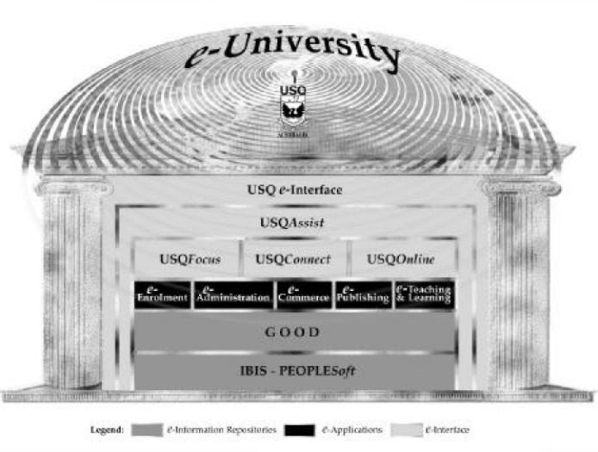
Fig. 4.1: Overview of USQ’s e-University Project [17].

Learner Relationship Management
The USQAssist initiative is deploying tracking and automation tools to manage the interaction between the University and both its existing and prospective students. The most efficient, cost–effective way to manage the 24 x 7 challenge is to deploy effective automation tools, as opposed to running three shift student service desks or employing online tutors in different continents.
The deployment of e-Customer Relationship Management (e-CRM) software as “Learner Relationship Management” will ultimately enable the use of a single toll free number integrated with an email–based enquiry tracking system that will exploit the fundamental strengths of the Internet in enhancing communication and managing information. The USQ e-interface is being developed through the application of a web services approach. The implementation of the approach has entailed the creation of an Internet Systems Design, Development and Integration Team, and an Online Systems Technical Management Committee (OSTMC) [17].

Automating e-Learning
In the USQ approach, many teaching staff make use of discussion groups, which entail students posting “reflections” via the asynchronous computer mediated communication (CMC) system. The teaching staff also post comments.
In the same vein, members of the teaching staff respond to student questions posted to the discussion group. Further, the experience demonstrates that other students often comment on the issues raised thereby enriching the depth and quality of the dialogue. The value of these contributions is particularly useful where students are giving examples of applications in different cultural contexts. While such fears can be allayed by the use of “one-to many” communication systems such as bulletin boards, mailing lists and threaded discussions, the underlying resource model is not significantly different from conventional on campus teaching, with a staff member being necessary to manage groups of approximately 20 students to maintain a reasonable quality of interaction and academic support. In contrast, the fifth generation Intelligent Flexible Learning Model has the potential to deliver major economies of scale in managing teaching and academic support through the exploitation of automated response systems (Fig 4.2).
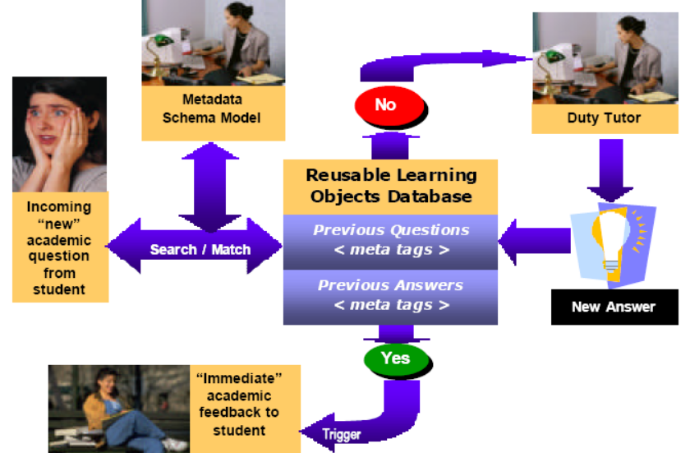
Fig. 4.2: Schematic representation of USQ’s 5th Generation Academic Productivity Enhancement System [17]

Upon receipt of an electronic query from a student, the staff member references the incoming question to a metadata schema model which has been devised for the course in question; the search engine then seeks an appropriate match with a previously asked question, which if successful, triggers a potential range of answers to the current question without further human intervention.
At this stage of development, the design of the system entails a tutor checking the validity of the match between the current question and the answers generated from the database before forwarding to the students with a single click of the mouse. Such a quality control mechanism may become redundant in the future. If no appropriate match is discovered in the database of previously answered questions, the query is automatically routed to the relevant tutor for an appropriate response, which is then added to the database with a single point and click.
Depending on the pedagogical design of the course, these responses can be directed to the whole cohort of students, to groups of students, or to individuals. The system has the advantage of providing more-or-less immediate pedagogical advice to students, a significant increase in institutional responsiveness, at minimal variable cost. It is worth noting that this system is not just aimed at reducing costs, USQ has a research program producing empirical evidence aimed at to validating the potential pedagogical efficacy of the approach, as illustrated by the following brief discussion of underlying instructional design theory and an associated exemplary investigation [17].

Comparison Criteria

Goals of the Automation
The USQAssist initiative is deploying tracking and automation tools to manage the interaction between the University and both its existing and prospective students. The design of the system entails a tutor checking the validity of the match between the current question and the answers generated from the database.

Foundation for Automation
The e-University Project was conceptualized in terms of three fundamental foci: the e-Information repositories, a variety of e-Applications and the e-Interface respectively.
In the USQ approach, many teaching staff make use of discussion groups, which entail students posting “reflections” via the asynchronous computer mediated communication (CMC) system.
In contrast, the fifth generation Intelligent Flexible Learning Model has the potential to deliver major economies of scale in managing teaching and academic support through the exploitation of automated response systems.

Pedagogical Foundation for the Automation
The system has the advantage of providing more-or-less immediate pedagogical advice to students, a significant increase in institutional responsiveness, at minimal variable cost. It is worth noting that this system is not just aimed at reducing costs, USQ has a research program producing empirical evidence aimed at to validating the potential pedagogical efficacy of the approach, as illustrated by the following brief discussion of underlying instructional design theory and an associated exemplary investigation.

Validation Tool Support
USQ has a research program producing empirical evidence aimed at to validating the potential pedagogical efficacy of the approach, as illustrated by the following brief discussion of underlying instructional design theory and an associated exemplary investigation.
At the stage of development, the design of the system entails a tutor checking the validity of the match between the current question and the answers generated from the database before forwarding to the students with a single click of the mouse.

Recommender system based on user-generated content

Introduction
Recommender systems apply statistical and knowledge discovery techniques to the problem of making recommendations during live user interaction. This part describes a novel approach of building recommender systems for the Web with the aid of usergenerated content. Recently certain communities of Internet users have engaged in creating high quality peer reviewed content for the Web. In this approach it’s been planning to extract the semantics of such user-generated content and to use these semantics to make more useful recommendations.
Recommender systems attempt to predict items (web pages, movies, books) that a user may be interested in, given some information about the user's profile. Collaborative filtering is the most popular approach to building such systems. Another method in generating recommendations is based on predicting users’ interests based on his/her past preferences. Both systems suffer from a number of deficiencies: mainly they both fail to recommend novel interesting topics.
In this part, it’s been avoided this difficulty by generating recommendations of Web pages with the aid of semantics, extracted from user-generated content. It is obvious that building a recommender system for Web pages that extracts semantics from all of the content on the Web would be very resource demanding. Instead it’s picked Wikipedia as source of user-generated semantics, which is a comprehensive and up-to-date corpus of knowledge and relationships between concepts [18].

Wikipedia
User-generated content refers to various kinds of content that is produced or primarily influenced by endusers. However, average quality of Web content is quite poor, as evidenced by vast amounts of Web spam and unverified information submitted by non-authoritative users. Therefore, instead of using the Web, Wikipedia is chosen as base, since it is a body of usergenerated content that is all encompassing and at the same time of high quality and peer reviewed.
Problem formulation
The main goal of this research is to develop a recommender system for the Web based on user generated content and novel semantic techniques. Instead of recommending web pages or sites, the system will recommend blogs. The overall system architecture is presented in figure 4.3. Within the content processing framework there two key processes: Wikipedia analysis (top of figure) and blogs processing (bottom of figure). Wikipedia is analyzed and create an ontology based on its structure. Then concepts are extracted and ranked from the blogs , making use of the ontology. Also in this stage blogs and ontology are associated through concepts. Then these associations are used to find blogs similar to users preference set (set of blogs that characterizes users interests) with the aid of the ontology.

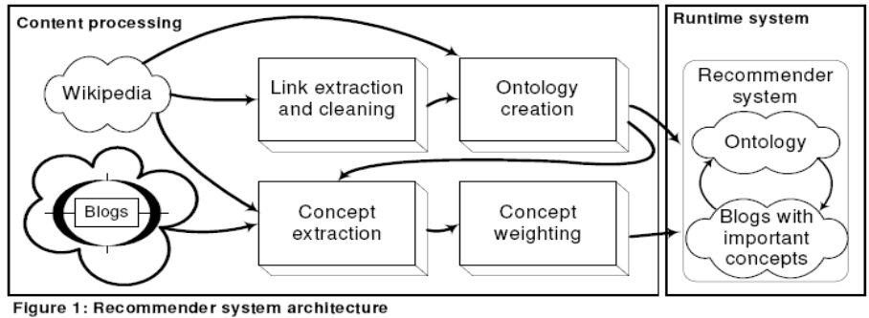
Fig 4.3: Recommender System Architecture[18]

Cleaning Wikipedia links: Though this is only a small part of information could be extracted from Wikipedia, users able to get results very quickly and rate their quality. For solving link cleaning task it is necessary to investigate how such low-quality links appear. Occasionally a rogue user will insert a bunch of irrelevant links into an otherwise quality section. In order for these methods to be applicable it’s needed to make sure that Wikipedia has the same properties.
So, web graph relates to the class of scale-free networks with most distinguishing characteristic are that their degree distribution follows a power law relationship. The second property of this class of networks is self-similarity: a large-enough supporter set should behave similar to the entire Web. The basic idea is to analyze rank distribution of some page in its neighborhood. Therefore emerging spam detection algorithms require the following properties: Power-law link distribution and Self-similarity. Link structure of the Wikipedia follows the power-law distribution and it follows that self-similarity holds for Wikipedia.
Ontology extraction: For the work it can’t be used only the link structure to make recommendations. So it’s needed to extract additional knowledge from Wikipedia that will help users select a few relevant links for recommendations. Therefore the second stage of Wikipedia processing deals with extracting semantic information from link and sections.
For now it will be used categories, “see also” links and general links in the sections. List of categories form a directed graph over the sections of Wikipedia, which can be very useful in pruning irrelevant links when making recommendations.
Web logs processing: In order to find blogs most similar to user preference set it’s necessary to extract terms from each blog and correlate these terms with concepts from the ontology. This will enable users to make recommendations based on these concepts. When blogs are correlated with concepts each blog will become associated with a large number of concepts. In order to identify essential concepts it’s used a modified tf-idf weighting scheme.
Generation of recommendations:At runtime the recommender system derives top-N recommendation from the ontology based on users preference set. Little research has been done on this topic. An ontology-based information retrieval model exploits ontology-based knowledge bases to improve search over large documents. This approach includes an ontology-based scheme for the semiautomatic annotation and retrieval of documents.

In this part it’s proposed a novel architecture for building recommendation systems and formulate the major directions of future work [18].

Comparison Criteria

Goals of the Automation
In this approach the semantics of such user-generated content was extracted and to use these semantics to make more useful recommendations via collaborative filtering method.
This part describes a novel approach of building recommender systems for the Web with the aid of user-generated content. New content is compared against user’s past preferences and similar items are recommended by generating recommendations of Web pages with the aid of semantics, extracted from user-generated content.

Foundation for Automation
At runtime the recommender system derives top-N recommendation from the ontology based on users preference set. An ontology-based information retrieval model exploits ontology-based knowledge bases to improve search over large documents. This approach includes an ontology-based scheme for the semiautomatic annotation and retrieval of documents.

Pedagogical Foundation for the Automation
In this approach no method is used for pedagogical foundation.

Validation Tool Support
In this approach no method is used for validation.

E-learning recommendation system

Introduction
In this part, the user-based collaborative filtering method is chosen as the primary recommendation algorithm, combined with online education. The requirement of a webbased e-learning recommendation system is analyzed, and divide the system workflow into five sections: data collection, data ETL, model generation, strategy configuration, and service supply. Moreover, an architecture is proposed, based on which further development can be accomplished. In this architecture, there are seven modules, and four of them are core modules: recommendation models database, recommendation system database, recommendation management, data/model management.

Collaborative Filtering
Learner-to-Learner correlation recommender systems recommend courses to a learner based on the correlation between that learner and other learners who have studied courses from the E-Learning site. This technology is known as “collaborative filtering”, because it originated as an information filtering technique that used group opinions to recommend
information items to individuals. In e-learning systems this is done in two ways. One, by having learners explicitly rate courses, in which case the system is moved part of the way towards Manual; the other, the learning is implicit from the parting patterns or click-stream behavior of the learners, in which case the system is pure Automatic. The proportion of actual parting hours to the total hours of the course is recorded as the implicit rating scores, and transformed to corresponding explicit rating scores, from 1 to 5. The learners’ rating scores can be donated in a m*n matrix, where m is the number of users, n is the number of courses, and Rj,k donates the rating of Coursek given by learnerj.
The most important step in CF-based recommender systems is that of computing the similarity between learners as it is used to form a proximity-based neighborhood between a target customer and a number of like-minded customers. In the e-learning recommendation system proximity between two learners a and b is measured by computing the Pearson correlation corrab, which is given by
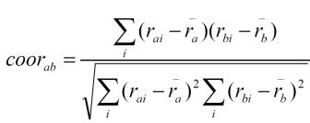 (1)
The final step of a CF-based recommender system is to derive the top-N recommendations from the neighborhood of customers. The association rule-based recommendation is used for performing the task. This technique is based on the association rule-based top-N recommendation technique. However, instead of using the entire population of learners to generate rules, this technique only considers the l neighbors while generating the rules. Non-personalized recommender systems is applied in e-learning system as well, which recommends courses to learners based on what other learners have said about the products on average [19].

SYSTEM DESIGN
The recommendation system is analyzed independently from the e-learning system, to reduce the extra burden of the e-learning site. The union of e-learning services, and recommender system services supplies the personalized recommending services together.
The central part of the services is the recommender system. The main workflow is the following five steps: Data Collection, ETL(extracted, transformed, loaded to data warehouse),Model Generation, Configuration, Service Supply.
The process above is a constant circuit, when the data in transaction database updates to a certain degree, the datasets and models in data warehouse have to be updated, in order to track the change of the users’ behaviors. The updating frequency differs to the system
requirements, usually at fixed period. This recommendation system consists of online and
offline parts, the online part receives the requirements, run the corresponding algorithm, and generates recommendation results; the offline part collects data, preprocess data and generates recommendation models. The Fig 4.4. gives out the architecture of the recommendation system.
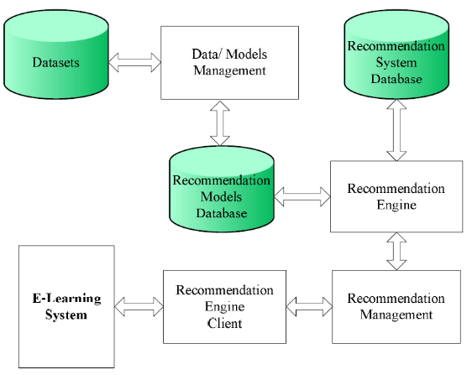
Figure 4.4. Architecture of E-Learning System [19]

Some core modules in Fig. 4.4 are introduced as following: Recommendation Models Database, Recommendation System Database, Recommendation Management, Data/model Management [19].

Comparison Criteria

Goals of the Automation
Non-personalized recommender systems is applied in e-learning system as well, which recommends courses to learners based on what other learners have said about the products on average.Non-personalized recommender systems are automatic, because they require little learner effort to generate the recommendation.

Foundation for Automation
In the e-learning recommendation system, the former one is adopted. In this case proximity between two learners a and b is measured by computing the Pearson correlation corr_{ab}.
The final step of a CF-based recommender system is to derive the top-N recommendations from the neighborhood of customers. The association rule-based recommendation is used for performing the task. This technique is based on the association rule-based top-N recommendation technique.

Pedagogical Foundation for the Automation
In this approach no method is used for pedagogical foundation.

Validation Tool Support
In this approach no method is used for validation.

EXPERT PERSONALIZED E-LEARNING RECOMMENDER SYSTEM

Introduction
This part proposes a framework for expert personalized e-learning recommender system (EPERS). An EPERS can help learners in finding learning materials that best suits their needs. In the proposed framework a rule-based expert system is developed to find suitable learning materials that best meet each learner’s requirements.
A Framework of EPERS
This section explains the main components of the EPERS as shown in Fig 4.5. This system consists of six components: Gathering Learner Information (GLI), Materials Recommendation Creation (MRC), Learner Profile (LP), Expert System (ES), Domain Knowledge Management (DKM) and Domain Knowledge Tree (DKT) [20].
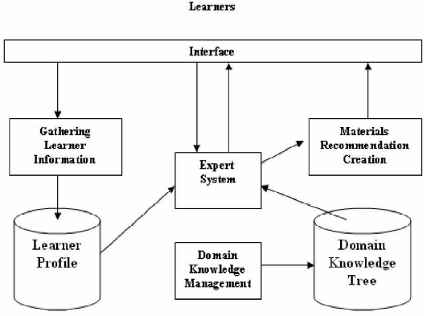
Fig. 4.5 The framework of EPERS [20]

Through GLI the learner initially registers to the system, during registration some personal settings are saved in the learner profile. The LP consists of learner’s: style, background, type (part time, full time), etc. In addition LP contains of all the information about learners, like their preferences, interests and knowledge levels, which can be obtained during the registration process. In DKM, the tutor can manage the material for the online course through creating and designing the DKT. The root of the DKT is the course name. The course is divided into chapters and that chapters are divided into sections and subsections. By using a rule-based expert system, the creation of final recommendation material list that based on learner’s requirements and on every answer given by the learner is achieved.

Expert System: Now that the data representation methodology of the expert recommendation system has been discussed, the focus of this part will turn to make the recommendation process. Any such accuracy requires the application to mimic the knowledge base of an experienced tutor. This knowledge base is encapsulated and applied by an expert system shell. Ideally, expert system engineers would be able to construct a general problem-solving machine, with an infinite knowledge base and comprehension of all problem-solving techniques . Since inference is an integral part of an expert system, it is helpful to implement an explanation facility within the expert system to explain the reasoning that occurred during the expert system’s deductions.

The scenarios steps of EPERS:
1. The expert system asks questions
2. The Learner answers
3. The expert system asks new questions, based on the previous answer
4. The learner thread (question-answer thread) inside the decision is recorded in History.
- Back to 2
A rule-based system maintains a collection of knowledge nuggets called facts. This collection is known as the knowledge base. It is somewhat akin to a relational database, especially in that the facts must have a specific structure.

Applications of EPERS
In order to deal with the multi-background learner situation, lecturers often indicate many choices of learning materials for each topic of the subject, and learners often rely on incomplete information, from their classmates and friends, when deciding which of the indicated learning materials to read and which of exercise questions to do.

Table 4.1: an example of learner information [20]
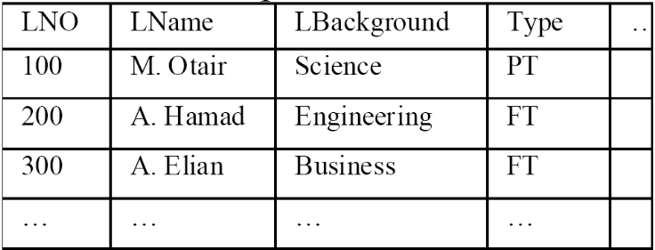
The proposed EPERS is expected to support learners in learning material choosing and can therefore handle such situation. Table 4.1 shows one of the main tables in the course learner MIS. The following line shows an example of recommendations.
Jess> (assert (Learner (LNo 100) (LName “M. Otair”)
(LBackground “Science) (section “Business_Rule”)))
<Fact-1>
Jess> (run)
M. Otair You have to read Business_rule section.

This part presents a framework of an expert personalized e-learning recommendation system and explains the main components of the system. The EPERS enhanced the productivity of learners/tutors in e-learning environments [20].

Comparison Criteria
Goals of the Automation
In the proposed framework a rule-based expert system is developed to find suitable learning materials that best meet each learner’s requirements.

Foundation for Automation
This part proposes a framework for expert personalized e-learning recommender system (EPERS). An EPERS can help learners in finding learning materials that best suits their needs. In the proposed framework a rule-based expert system is developed to find suitable learning materials that best meet each learner’s requirements.

Pedagogical Foundation for the Automation
In this approach no method is used for pedagogical foundation.

Validation Tool Support
In this approach no method is used for validation.

Conclusions and Future Work

Table of Comparison Criteria

As mentioned previously, 15 approaches were compared to each other through 4 comparison criteria, which are shown in below table:

Table 6.1. Comparison Criteria
CC  Approaches | Goals of the Automation | Foundation for Automation | Pedagogical Foundation for the Automation | Validation Tool Support
Modding as an Open Source Approach | - Garry's Mod or the AMX Mod X modmaking package | - open APIs  - migration across software versions  - network data content/hypertext transfer protocols  - representational state transfer | - software system design practice | - user-controlled character appearance  - capabilities, opponent bots  - cheat bots  - non-player characters
The case of 1492 | - minimize the cost and effort needed for introducing accessibility | - analyzing the game description XML files and art resources  - generating regular grammar
My first day at work | - minimize the cost and effort needed for introducing accessibility | - match different user profiles  - Produces additional description files and resources.
Petri Nets for Representing Story Plots in Serious Games | - features an abstract story manager for running and verifying PNA-plots | The PNA-model:  - containers  - tokens  - actions  - triggers | - Interactive–narrative | - application TEST
Cellular Automata and DEVS Methodologies | - how cell-DEVS implement computer simulations that can be used as digital serious games. | - CD++ environment  - CA and DEVS-based methodologies in serious game development
Toward Supporting Stories with Procedurally Generated Game Worlds | - which NPC or item performs the associated behavior  - instigate traversals through the appropriate branches of the ABL behavior tree. | game plot adaptation algorithm:  - Addition  - Deletion  - Environment Type Change |  | - evaluation criteria
An Offline Planning Approach to Game Plotline Adaptation | - generate plotline from scratch | - offline algorithm for individual players  - scaling up the delivery of on-demand, customized entertainment content
Modeling Player Experience for Content Creation | - serving players new game content such as levels and game modes based on individual | - GA |  | - threefold cross-validation technique on the three possible independent training and validation data sets
Automated Game Design | - performing common-sense reasoning about game verbs and nouns | - combination of the ConceptNet and WordNet knowledge bases | - automated game-design system
User-preference-based automated level generation for platform games | - learns the preferences for various features of user/player | - (feasible) individual (graph) found by the genetic algorithm | - two pre-game questions | - fitness function
Automatic Facial Expression Recognition for Intelligent Tutoring Systems | - how automatic real-time facial expression recognition estimate the difficulty level | - AU outputs and their temporal first derivatives | - self-reported difficulty scores  - video lecture viewing task  - training on less than two minutes of recorded data | - system predict the subjects’ self-reported difficulty  - testing on a separate validation set
Automating e-Learning | - manage the interaction between the University and both its existing and prospective students | - asynchronous computer mediated communication (CMC) | - more-or-less immediate pedagogical advice to students | - research program producing empirical evidence  - tutor checking
Recommender system based on user-generated content  Serious Educational Game Customization | - make more useful recommendations via collaborative filtering method | - ontology-based information retrieval model
E-learning recommendation system | - recommends courses to learners based on what other said about the products | - user-based collaborative filtering method  - Pearson correlation
EXPERT PERSONALIZED E-LEARNING RECOMMENDER SYSTEM | - find suitable learning materials that best meet learner’s requirements | - EPERS  - rule-based expert system

References

[1] Clark Verbrugge, “A Structure for Modern Computer Narratives”, McGill University, Montreal, Quebec, CANADA.
[2] Georgios N. Yannakakis, Julian Togelius, "Experience-Driven Procedural Content Generation”, Affective Computing, IEEE Transactions on, Vol. 2, No. 3. (July 2011), pp. 147-161, 2011.
[3] Walt Scacchi, “Modding as an Open Source Approach to Extending Computer Game Systems”, Open Source Systems: Grounding Research, Proc. 7th. IFIP Intern. Conf. Open Source Systems, 62-74, IFIP ACIT 365, Salvador, Brazil, October 2011.
[4] Maiga Chang, Wu-Yuin Hwang, Ming-Puu Chen, Wolfgang Mueller, “Edutainment Technologies. Educational Games and Virtual Reality/Augmented Reality Applications”, 6th International Conference on E-learning and Games, Edutainment 2011, Taipei, Taiwan, September 7-9, 2011.
[5] IEEE Standard Glossary of Software Engineering Terminology Standards, ElectronicsEhgineers, New York, NY,USA.
[6] Morcos, M.M. , Soldan, D.L. “Assessing student learning in a distance education environment”, Dept. of Electr. & Comput. Eng., Kansas State Univ., Manhattan, KS, USA , FIE '00 Proceedings of the 30th Annual Frontiers in Education - Volume 02, Pages S3D/5vol.2-S3D/15 , IEEE Computer Society Washington, DC, USA,2000.
[7] Barton Pursel, “Educational Gaming and Simulation: Current Research and Efforts in Assessment”, Undergraduate Education and Instructional Researcher, the Pennsylvania State University.
[8] Javier Torrente, Ángel del Blanco, Ángel Serrano-Laguna, José Ángel VallejoPinto, Pablo Moreno-Ger, Baltasar Fernández-Manjón, “Towards Universal Game Development in Education Automatic and Semiautomatic Methodologies”, adfa, p. 1, 2011.© Springer-Verlag Berlin,Heidelberg,2011.
[9] Cyril Brom, Toma´s Holan, Daniel Balas, Adam Abonyi, V´ıt Sisler, Leo Galambos, “Petri Nets for Representing Story Plots in Serious Games”, AISB Journal 2(1), © SSAISB, 2010
[10] Gabriel Wainer, Qi Liu, Olivier Dalle, Bernard P. Zeigler, “Applying Cellular Automata and DEVS Methodologies to Digital Games: A Survey”, Simulation & Gaming, SAGE Publications, 2010.
[11] Ken Hartsook, Alexander Zook, Sauvik Das, and Mark O. Riedl, “Toward Supporting Stories with Procedurally Generated Game Worlds”, Georgia Institute of Technology, Atlanta, GA 30332 USA.
[12] Christopher Pedersen, Julian Togelius, Georgios N. Yannakakis, “Modeling Player Experience for Content Creation Comparison Criteria”, Center for Computer Games Research, IT Universityof Copenhagen, Denmark.
[13] Mark J. Nelson1 and Michael Mateas, “Towards Automated Game Design”, College of Computing, Georgia Institute of Technology, Atlanta, Georgia, USA, Computer Science Department University of California, Santa Cruz, Santa Cruz, California, USA.
[14] Nick Nygren, Jorg Denzinger, Ben Stephenson, John Aycock, “User-preference-based automated level generation for platform games”, Department of Computer Science, IEEE, University of Calgary, University Drive NW, Calgary, Canada, 2011.
[15] Boyang Li, Mark O. Riedl, “An Offline Planning Approach to Game Plotline Adaptation”, Proceedings of the Sixth AAAI Conference on Artificial Intelligence and Interactive Digital Entertainment, AIIDE 2010, October 11-13, Stanford, California, USA, 2010.
[16] Jacob Whitehill, Marian Bartlett, and Javier Movellan, “Automatic Facial Expression Recognition for Intelligent Tutoring Systems”, Machine Perception Laboratory, University of California, San Diego
[17] James C Taylor, “Automating e-Learning: The Higher Education Revolution”, University of Southern Queensland, Australia.
[18] Turdakov Denis, “Recommender system based on user-generated content”, Institute for System Programming, RAS.
[19] Huiyi Tan , Yong Li, Junfei Guo, “E-Learning Recommendation System”, International Conference on Computer Science and Software Engineering, 2008.
[20] Mohammed A. Otair, Ahmed Q. Al Hamad, “EXPERT PERSONALIZED E-LEARNING RECOMMENDER SYSTEM”, Jordan University of Science and Technology and Al al-Bayt University, JORDAN.

Appendix A. title here

